Question 1

delimiter &&

create function convert_km_to_m ( km int)

returns int

deterministic

begin

declare c int ;

set c = km *1000;

return (c);

end &&

create function convert_km_to_cm ( km int)

returns int

deterministic

begin

declare c int ;

set c = km *100000;

return (c);

end &&

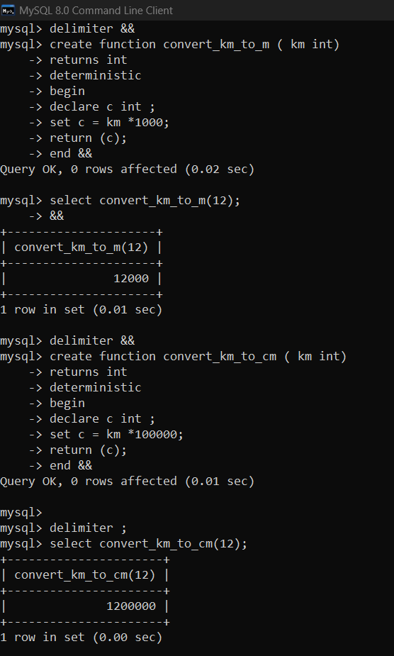

Question 2

delimiter &&

create function convert_into_words( i int)

returns varchar(1000)

deterministic

begin

declare k int;

declare ii int default 0;

declare ans varchar (1000) default '';

while i!=0 do

set ii =(10* ii) + (i mod 10);

set i = i / 10;

end while;

set k=ii;

while ii!=0 do

set i = (ii mod 10);

set ii = ii/10;

if i = 1 then

set ans = concat(ans,' ','one');

elseif i=2 then

set ans = concat(ans,' ','two');

elseif i=3 then

set ans = concat(ans,' ','three');

elseif i=4 then

set ans = concat(ans,' ','four');

elseif i=5 then

set ans = concat(ans,' ','five');

elseif i=6 then

set ans = concat(ans,' ','six');

elseif i=7 then

set ans = concat(ans,' ','seven');

elseif i=8 then

set ans = concat(ans,' ','eight');

elseif i=9 then

set ans = concat(ans,' ','nine');

else set ans = concat(ans,' ','zero');

end if;

end while;

return ( ans) ;

end &&

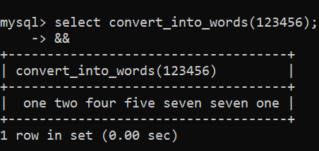

Question 3

create function reverse_int( i int)

returns int

deterministic

begin

declare ii int default 0;

while i!=0 do

set ii =(10* ii) + (i mod 10);

set i = i / 10;

end while;

return (ii);

end&&

select reverse_int(123)&&

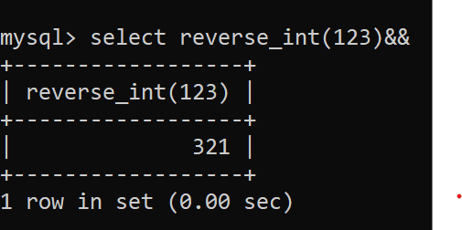

Question 4

a)

create table customers (id int primary key , name varchar(20) ,address int , salary decimal(17,3) );

alter table customers add column age int;

insert into customers (id,age) values (1,32),(2,25),(3,23),(4,25),(5,27),(6,22);

delimiter &&

create procedure ins (in nk varchar(20) ,in sal decimal(17,3),out i int)

begin

select count(*) into i from customers where id=5;

update customers set name=nk, salary=sal where id=5;

end&&

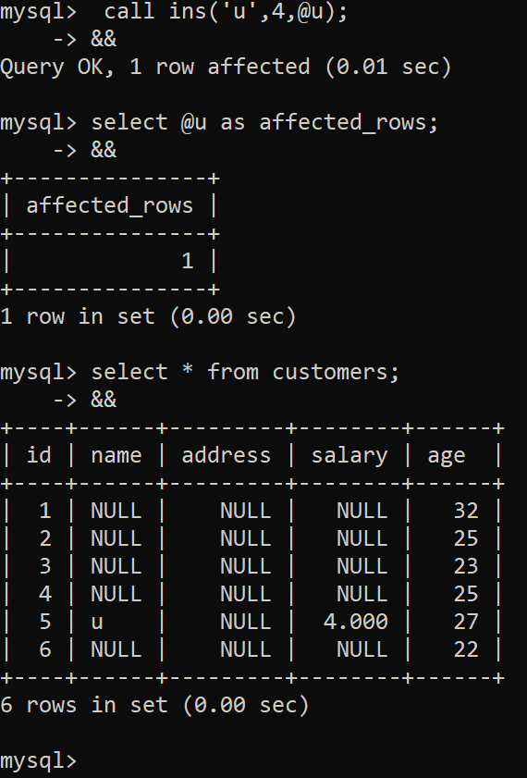

B)

delimiter &&

create procedure a(out i int)

begin

declare finish int default 0;

declare k varchar (100);

declare cur cursor for select name from customers where age>25;

declare continue handler for not found set finish =1;

set i =0;

open cur;

get_data : loop

fetch cur into k;

if finish=1 then leave get_data;

end if;

set i=i+1;

end loop get_data;

close cur;

end &&

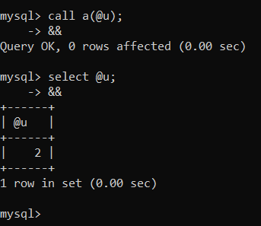

Question 5

create table product ( p_code int primary key , price int ) ;

insert into product values (1,1234),(2,777),(3,1000);

create table product_logs ( p_code int , price int , update_data date ) ;

delimiter &&

create trigger b_u_p

before update on product for each row

begin

insert into product_logs values (old.p_code,old.price,sysdate());

end &&

